
Digital Buddiess Nagpur
3rd Floor, Narang Tower, Palm Rd, Collectors Colony, Civil Lines, Nagpur, Maharashtra-440001
Phone no. : 9404085316, 9545871746
Email : buddiess.digital@gmail.com State: 27-Maharashtra

Tax Invoice

Bill To |  |  |  | Invoice Details  Invoice No. Date :
# Item name | HSN/ SAC | Quantity | Price/ Unit | Amount
1 |  | 1 | ₹ | ₹
Total |  | 1

Invoice Amount In Words

Terms and Conditions
All invoices raised needs to be paid within 2 calendar days from date of invoice. If not done, panalty will be applicable
Sub Total ₹

Total ₹
Received ₹ 0.00
Balance ₹

Pay To:
Bank Name : BANK OF BARODA, MAHAL-NAGPUR BRANCH
Bank Account No. : 11970100020463 Bank IFSC code : BARB0MAHNAG
Account holder's name : Bhojendra Soni
For :Digital Buddiess Nagpur
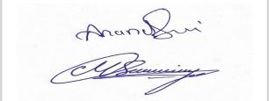
Authorized Signatory

